Chapters 6 to 8 Homework

Jagan Chidella

**Real Number Representation:**

1. Represent the number 263.3 in 32-bit floating point representation.
2. Represent the number -17.625 in 32-bit floating point representation.

**(a)** Using the 2’s complement method, express the following negative numbers in binary (use 5-bit binary system) -7, -12.

**(b)** Using the 2’s complement method, find the value of the following:

(i) 39 + (-25)

(ii) 43 - (+71)

**Boolean Algebra, Logic Gates, Karnaugh Maps:**

1. Simplify the following Boolean Expression using Boolean laws: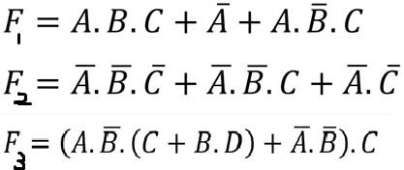

(mention which laws you are using in which step)

1. Given the Boolean function: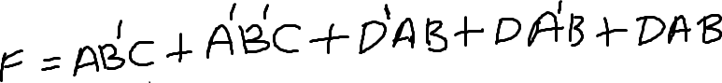

find the following:

1. Obtain the truth table of the function.
2. Simplify the function to a minimum number of laterals using Boolean algebra.
3. Obtain the truth table of the function using the simplified expression.
4. For the following function:

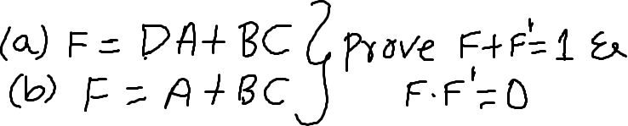

1. Demonstrate by means of truth tables the validity of the following identities:
2. De-Morgan’s theorem for three variables: (A+B+C)’ = A’B’C’ and (ABC)’=A’+B’+C’
3. The distributive law: A+BC = (A+B) (A+C)
4. Reduce the following Boolean expressions to the indicated number of literals (using laws and mention names of laws you are using in which step):

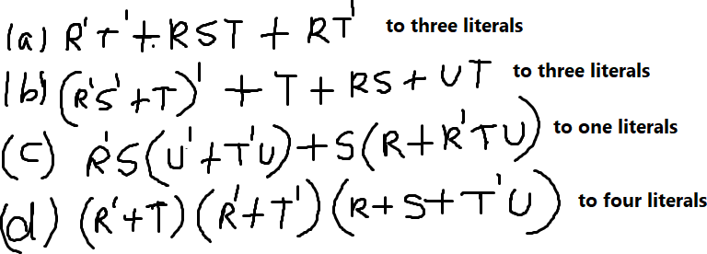

1. Using only minimum gates, draw a logic gate diagram for the following expressions:



**Karnaugh Maps:**

1. Simply the following functions using 3 variable maps:

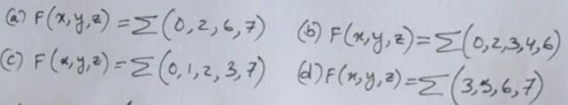

1. Simplify the following Boolean expressions, using three-variable maps:

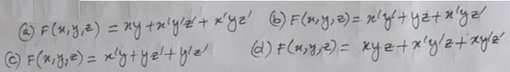

**Induction and Recursion:**

1. Prove by induction the recursive formula for the Fibonacci numbers:

F1 = 1

F2 = F1

F3 = F1+F2

F4 = F2+F3

F5 = F3+F4

Define the two Recursive Formula Rules, with the basic rule and the recursive rule.

Then, using the below information, validate the formula for Fn.

n = 1 2 3 4 5 6 7 8 9 10 11 12...

|  |  |  |  |  |  |  |  |  |  |  |
| --- | --- | --- | --- | --- | --- | --- | --- | --- | --- | --- |
| n = | 1 | 2 | 3 | 4 | 5 | 6 | 7 | 8 | 9 | 10 |
| fn = | 1 | 1 | 2 | 3 | 5 | 8 | 13 | 21 | 34 | 55 |
| sum fn = | 1 | 2 | 4 | 7 | 12 | 20 | 33 | 54 |  |  |

Notice from the table it appears that the sum of the first n terms is the (nth+2) term minus 1

Let P(n) be the statement f1+f2+f3+...fn=f(n+2) – 1

Prove P(n), for all n.